Activity | Data Type
Number of beatings from Wife | Discrete
Results of rolling a dice | Discrete
Weight of a person | Continuous
Weight of Gold | Continuous
Distance between two places | Continuous
Length of a leaf | Continuous
Dog's weight | Continuous
Blue Color | Discrete
Number of kids | Discrete
Number of tickets in Indian railways | Discrete
Number of times married | Discrete
Gender (Male or Female) | Discrete
Q1) Identify the Data type for the Following:

Q2) Identify the Data types, which were among the following
Nominal, Ordinal, Interval, Ratio.
Data | Data Type
Gender | Nominal
High School Class Ranking | Ordinal
Celsius Temperature | Interval
Weight | Ratio
Hair Color | Nominal
Socioeconomic Status | Ordinal
Fahrenheit Temperature | Interval
Height | Ratio
Type of living accommodation | Ordinal
Level of Agreement | Ordinal
IQ(Intelligence Scale) | Ratio
Sales Figures | Interval
Blood Group | Nominal
Time Of Day | Ratio
Time on a Clock with Hands | Ratio
Number of Children | Ordinal
Religious Preference | Nominal
Barometer Pressure | Ratio
SAT Scores | Ratio
Years of Education | Interval

Q3) Three Coins are tossed, find the probability that two heads and one tail are obtained?
Ans) When 3 coins are tossed the total number of possible combinations are 2^3=8
These 8 possible combinations are= HHH,HHT,HTH,HTT,THH,THT,TTH,TTT.
Possibility of getting two heads and one tail is = HHT,HTH,THH=3
The probability that two heads and one tail are obtained=3/8= 0.375

Q4) Two Dice are rolled, find the probability that sum is
- Equal to 1
- Less than or equal to 4
- Sum is divisible by 2 and 3

Ans) When 2 Dice are rolled the total number of Possible combinations are=6^2=36.
a)Event that sum is equal to 1= 0
Probability= 0/36 = 0
b)Event that the sum is less than or equal to 4 = 6
Probability=6/36= 0.16666
c)Event that sum is divisible by 2 and 3 = 5
Probability= 5/36= 0.13888

Q5) A bag contains 2 red, 3 green and 2 blue balls. Two balls are drawn at random. What is the probability that none of the balls drawn is blue?
Ans) Total number of balls = 2+3+2=7
When 1st ball is drawn
P(red balls)=2/7
P(green balls)=3/7
The probability that the first ball is not blue= 2/7 + 3/7 = 5/7
When 2nd ball is drawn
The probability that the second ball is not blue= 4/6
P(neither ball is blue)= 5/7*4/6 = 20/42= 10/21

Q6) Calculate the Expected number of candies for a randomly selected child
Below are the probabilities of count of candies for children (ignoring the nature of the child-Generalized view)
CHILD | Candies count | Probability
A | 1 | 0.015
B | 4 | 0.20
C | 3 | 0.65
D | 5 | 0.005
E | 6 | 0.01
F | 2 | 0.120
Child A – probability of having 1 candy = 0.015.
Child B – probability of having 4 candies = 0.20
Ans) Expected number of candies for a randomly selected child =
1*0.015+4*0.20+3*0.65+5*0.005+6*0.01+2*0.120= 0.015+0.8+1.95+0.025+0.06+0.24= 3.09
Expected number of candies for a randomly selected child = 3.09
Q7) Calculate Mean, Median, Mode, Variance, Standard Deviation, Range & comment about the values / draw inferences, for the given dataset
- For Points,Score,Weigh>
Find Mean, Median, Mode, Variance, Standard Deviation, and Range and also Comment about the values/ Draw some inferences.
Use Q7.csv file

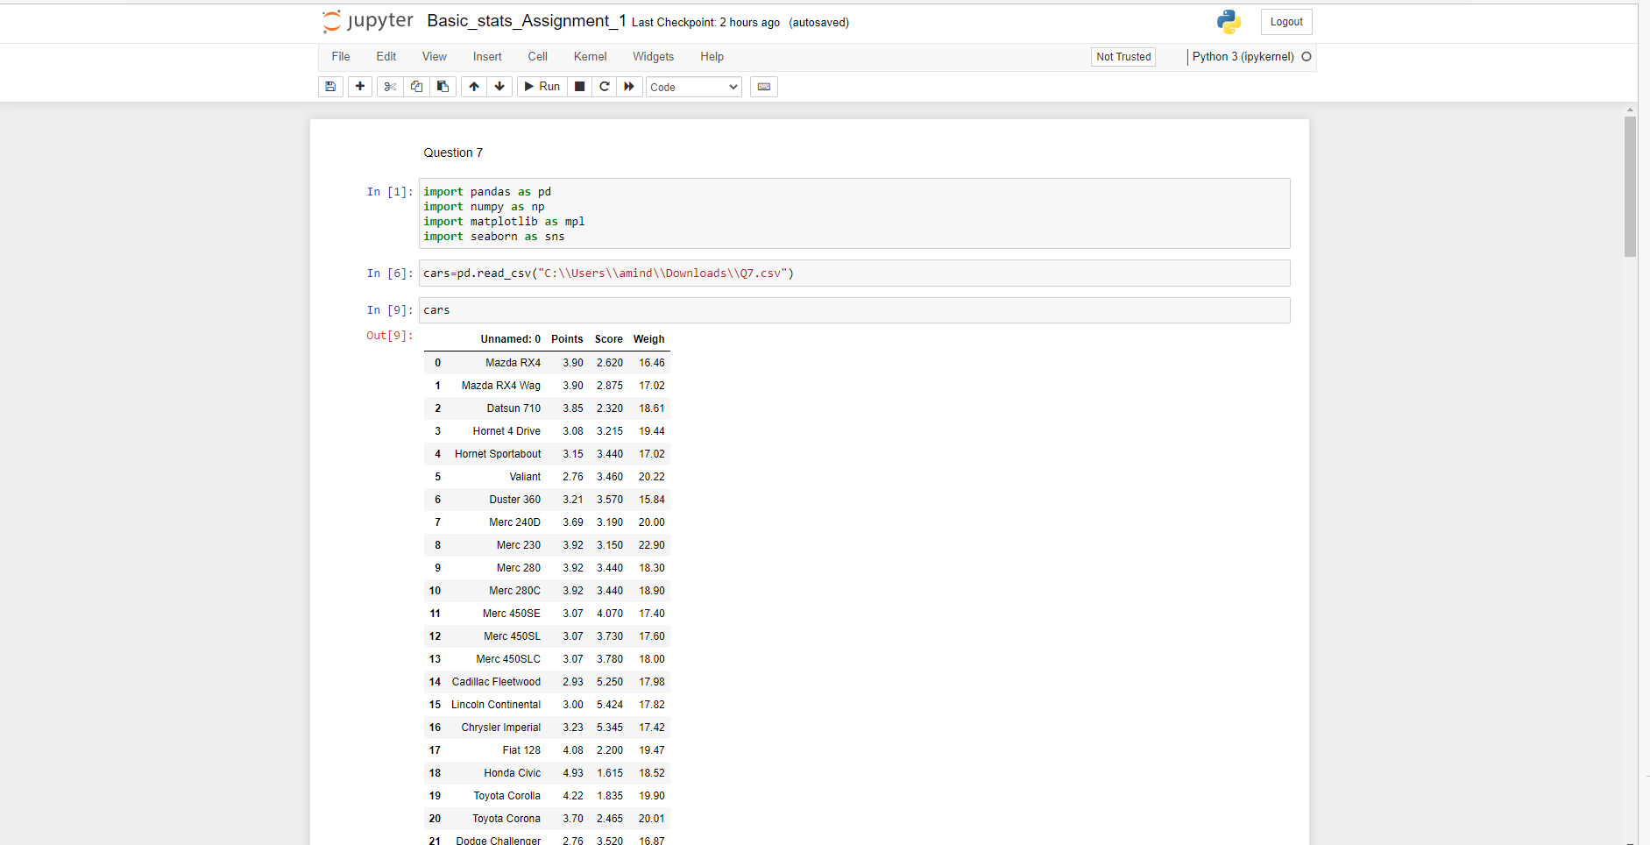

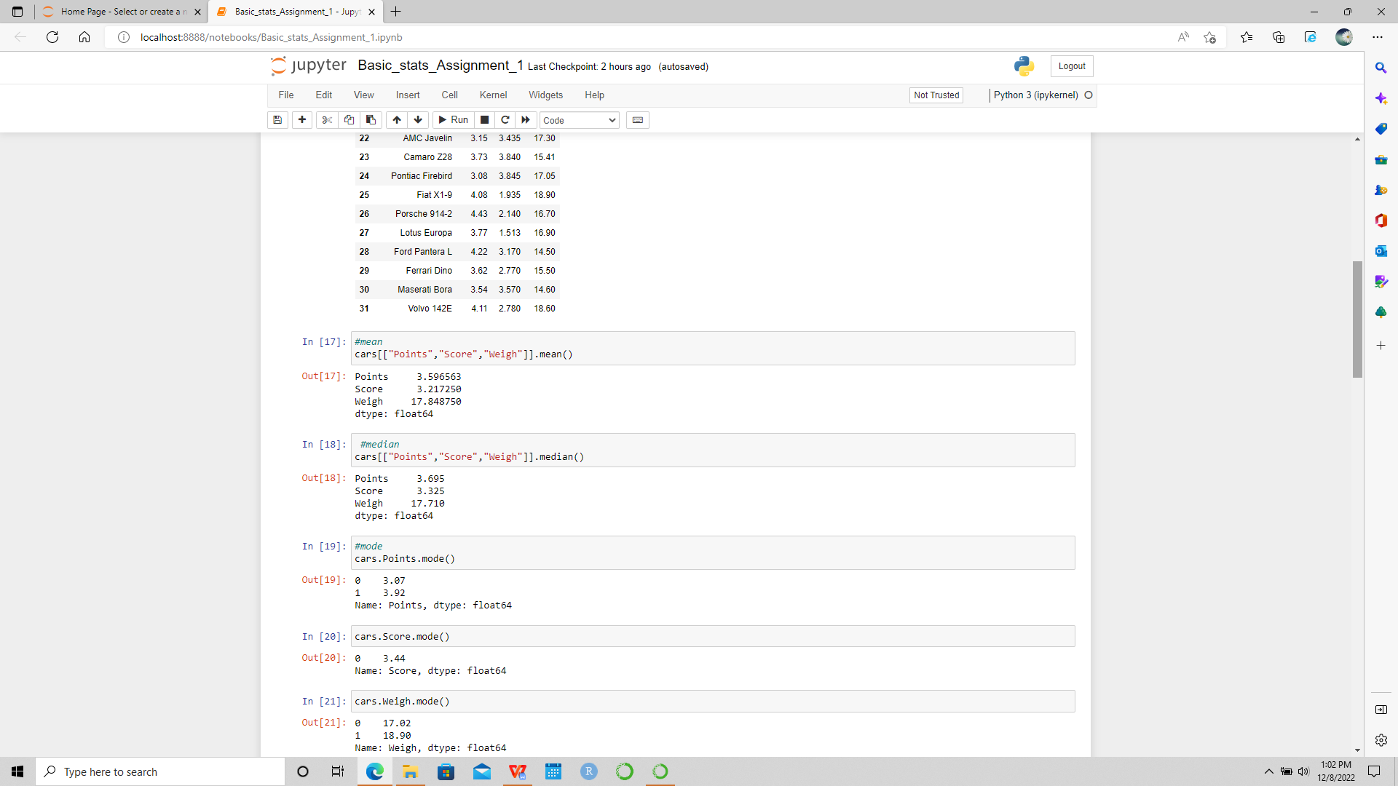

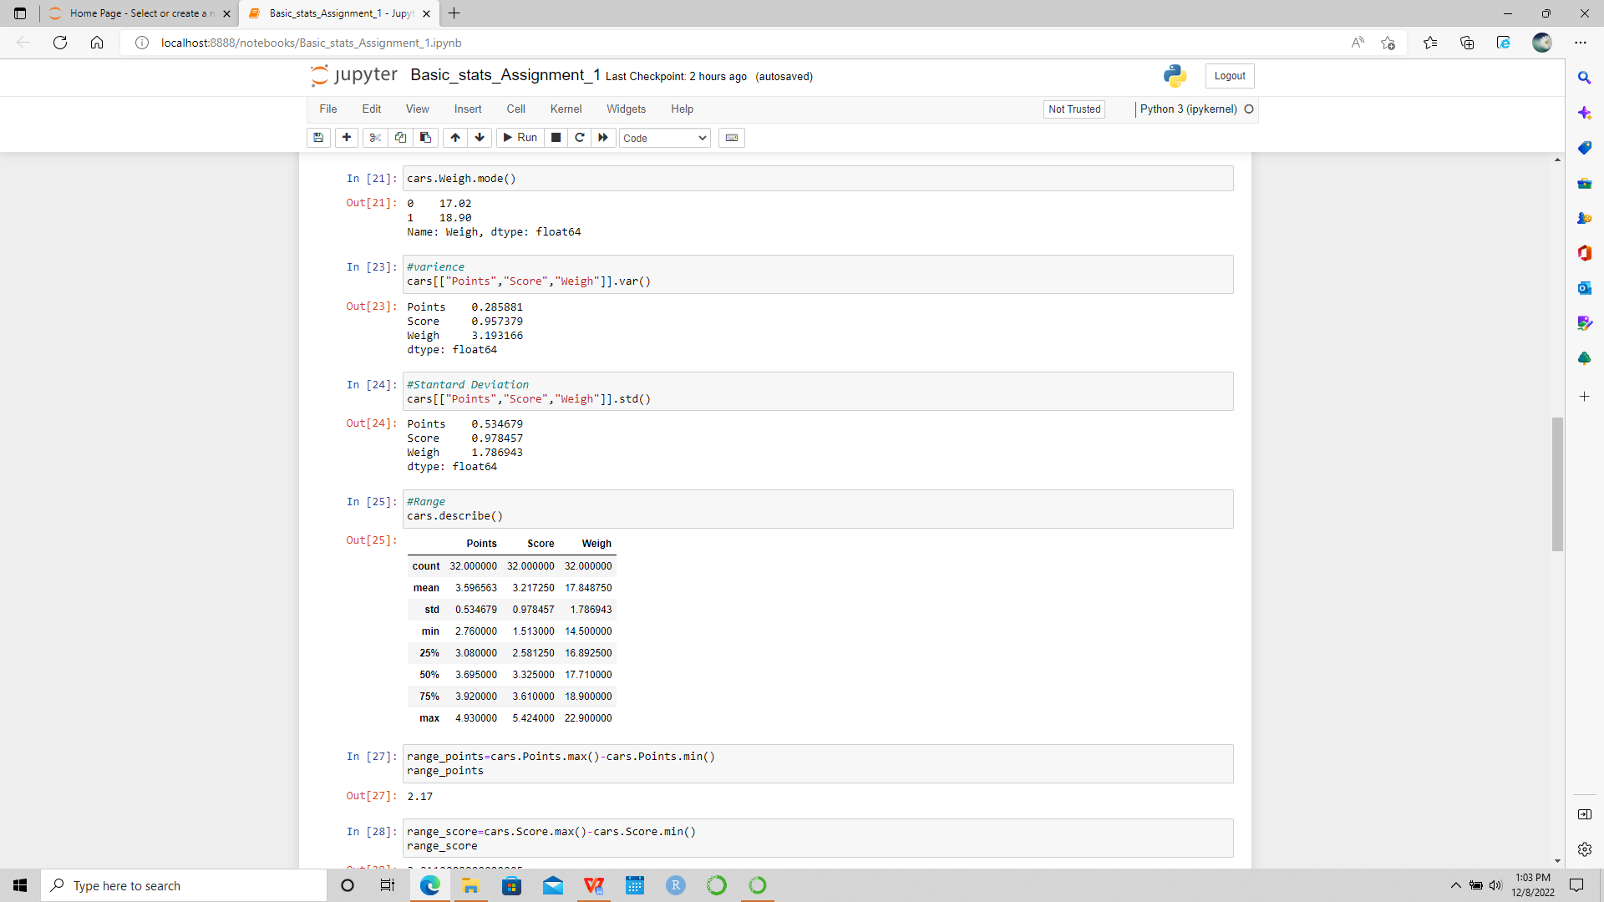

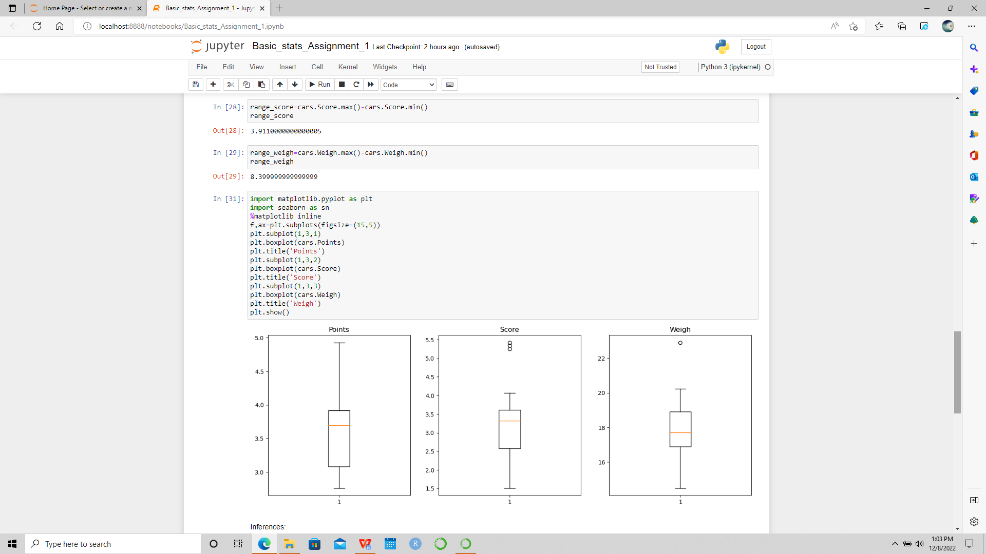

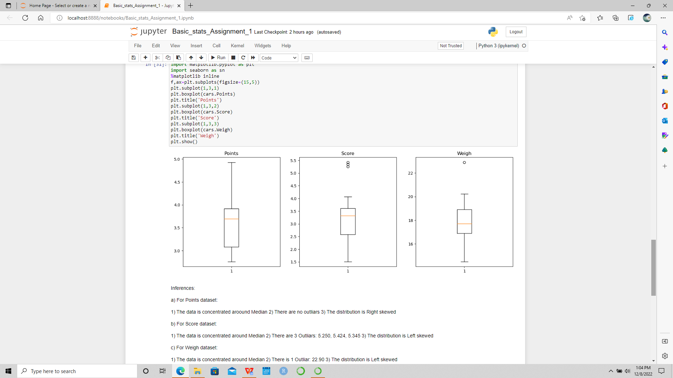
Ans) Mean : Points 3.596563
Score 3.21725
Weigh 17.848750

Median: Points 3.695
Score 3.325
Weigh 17.710

Mode: Point = 0 3.07
1 3.92
Score=0 3.44

Weigh=0 17.02
1 18.90

Variance: Points 0.285881
Score 0.957379
Weigh 3.193166

Standard deviation =Points 0.534679
Score 0.978457
Weigh 1.786943

Range_points=2.17
Range_score=3.9110000000000005
Range_weigh= 8.399999999999999

Q8) Calculate Expected Value for the problem below
- The weights (X) of patients at a clinic (in pounds), are
108, 110, 123, 134, 135, 145, 167, 187, 199
Ans) Assume one of the patients is chosen at random. What is the Expected Value of the Weight of that patient?
Probability of selecting each patient= 1/9
E(x)= 108,110,123,134,135,145,167,187,199
P(x)=1/9
Expected value= (1/9)(108+ 110+123+134+ 135+145+167+187+199)
Expected value=(1/9)(1308) = 145.333

Q9) Calculate Skewness, Kurtosis & draw inferences on the following data
Cars speed and distance
Use Q9_a.csv
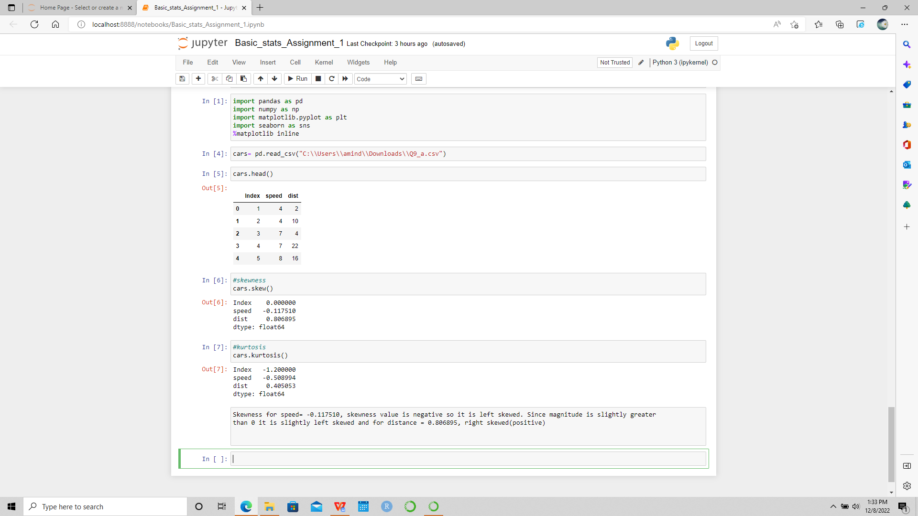
 | Speed | Distance
Skewness | -0.117510 | 0.806895
Kurtosis | -0.508994 | 0.405053
Interference:
Skewness for speed= -0.117510, skewness value is negative so it is left skewed. Since magnitude is slightly greater than 0 it is slightly left skewed and for distance = 0.806895, right skewed(positive).

SP and Weight(WT)
Use Q9_b.csv

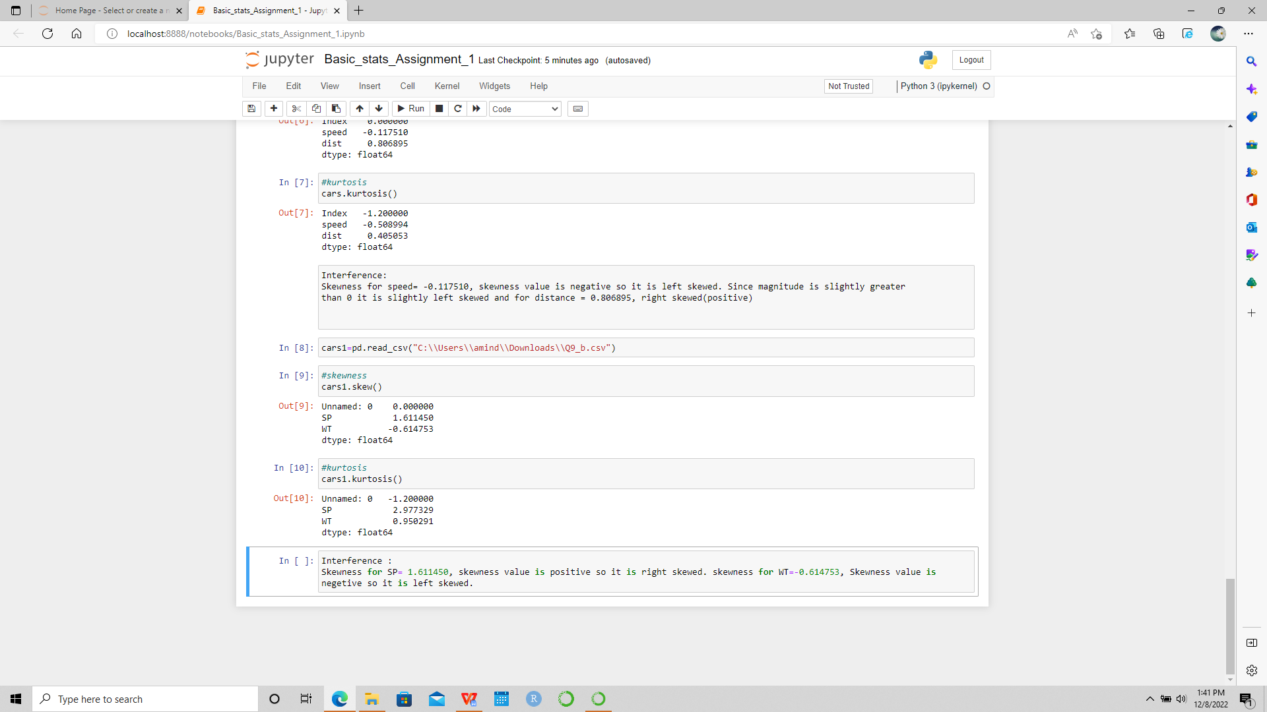
 | SP | WT
Skewness | 1.611450 | -0.614753
Kurtosis | 2.977329 | 0.950291

Interference:
Skewness for SP= 1.611450, skewness value is positive so it is right skewed. skewness for WT=-0.614753, Skewness value is negetive so it is left skewed.

Q10) Draw inferences about the following boxplot & histogram
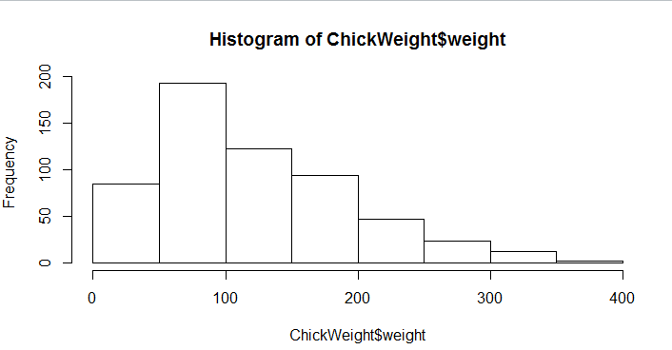

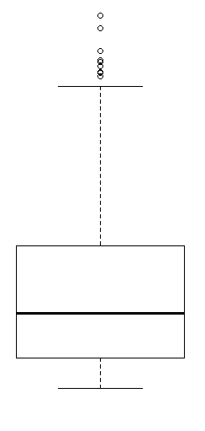
Ans) The histograms peak has right skew and tail is on right. Mean > Median. We have outliers on the higher side

The box-plot has outliers on the maximum side.

Q11) Suppose we want to estimate the average weight of an adult male in Mexico. We draw a random sample of 2,000 men from a population of 3,000,000 men and weigh them. We find that the average person in our sample weighs 200 pounds, and the standard deviation of the sample is 30 pounds. Calculate 94%,98%,96% confidence interval?
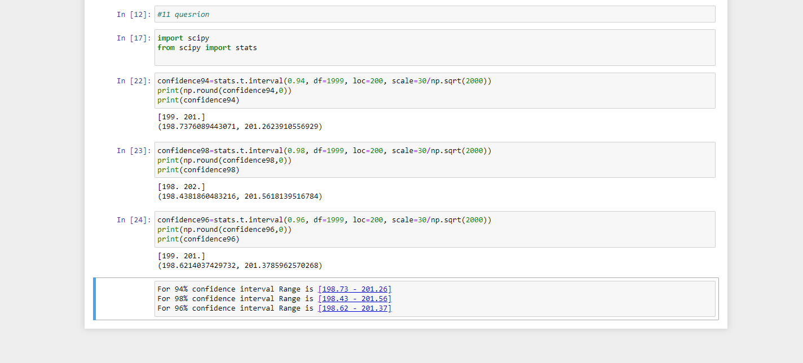
For 94% confidence interval Range is [198.73 - 201.26]
For 98% confidence interval Range is [198.43 - 201.56]
For 96% confidence interval Range is [198.62 - 201.37]

Q12) Below are the scores obtained by a student in tests
34,36,36,38,38,39,39,40,40,41,41,41,41,42,42,45,49,56
- Find mean, median, variance, standard deviation.
- What can we say about the student marks?

- Mean =41
Median =40.5
Variance =25.52
Standard deviation =5.05

- We don’t have outliers and the data is slightly skewed towards right because mean is greater than median.

Q13) What is the nature of skewness when mean, median of data are equal?
Ans) No skewness is present we have a perfect symmetrical distribution.

Q14) What is the nature of skewness when mean > median ?
Ans) Skewness and tail is towards Right.

Q15) What is the nature of skewness when median > mean?
Ans) Skewness and tail is towards left.

Q16) What does positive kurtosis value indicates for a data ?
Ans) Positive kurtosis means the curve is more peaked and it is Leptokurtic.

Q17) What does negative kurtosis value indicates for a data?
Ans) Negative Kurtosis means the curve will be flatter and broader.

Q18) Answer the below questions using the below boxplot visualization.

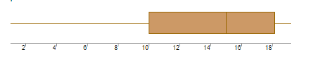
What can we say about the distribution of the data?
Ans) The above boxplot is not normally distributed the median is towards the higher value.

What is nature of skewness of the data?
Ans) The data is a skewed towards left. The whisker range of minimum value is greater than maximum.

What will be the IQR of the data (approximately)?
Ans) The Inter Quantile Range= Q3 upper quartile - Q1 lower quartile = 18-10 =8
Q19) Comment on the below Boxplot visualizations?
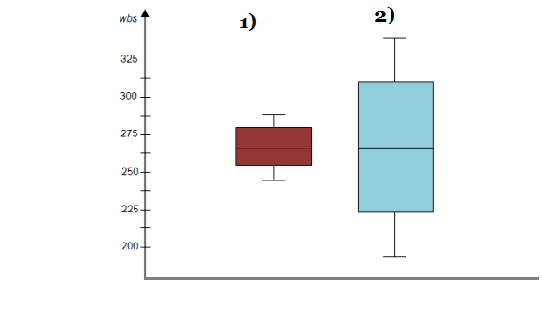
Draw an Inference from the distribution of data for Boxplot 1 with respect Boxplot 2.
Ans) First there are no outliers. Second both the box plot shares the same median that is approximately in a range between 275 to 250 and they are normally distributed with zero to no skewness neither at the minimum o maximum whisker range.
Q 20) Calculate probability from the given dataset for the below cases

Data _set: Cars.csv
Calculate the probability of MPG of Cars for the below cases.
MPG <- Cars$MPG
  - P(MPG>38)
  - P(MPG<40)
c. P (20<MPG<50)
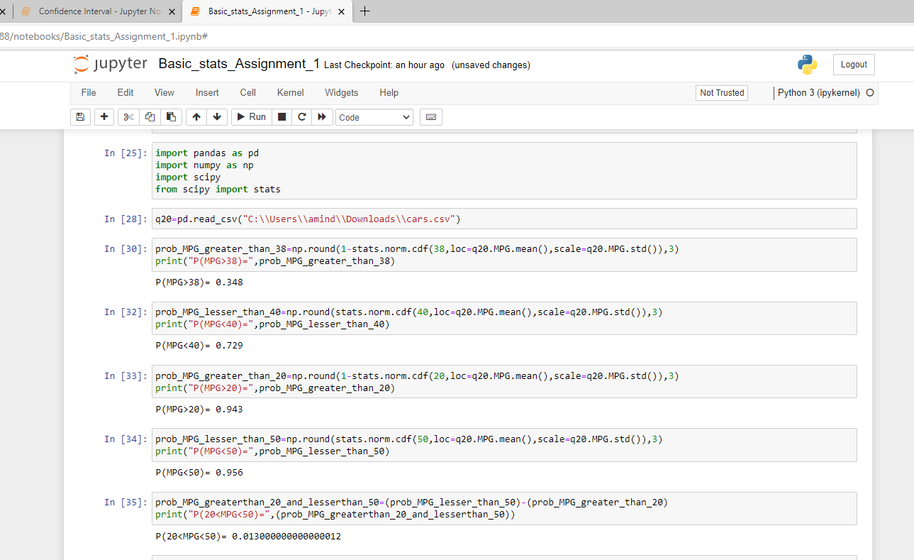
a)P(MPG>38)= 0.348
b)P(MPG<40)= 0.729
c)P(MPG>20)= 0.943
P(MPG<50)= 0.956
P(20<MPG<50)= 0.013000000000000012

Q 21) Check whether the data follows normal distribution
- Check whether the MPG of Cars follows Normal Distribution
Dataset: Cars.csv
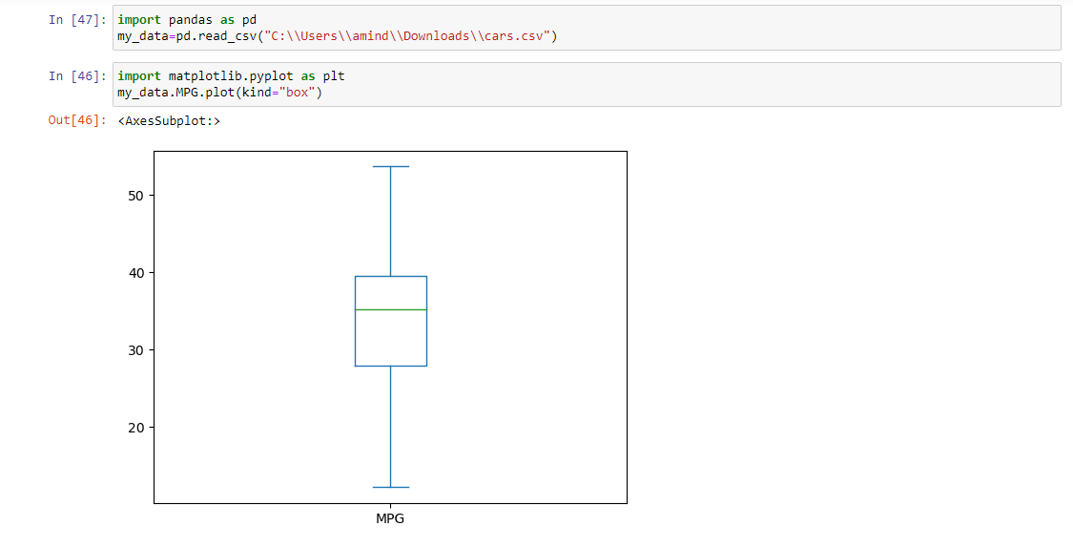
Ans) MPG of cars follows normal distribution.

- Check Whether the Adipose Tissue (AT) and Waist Circumference(Waist) from wc-at data set follows Normal Distribution
Dataset: wc-at.csv
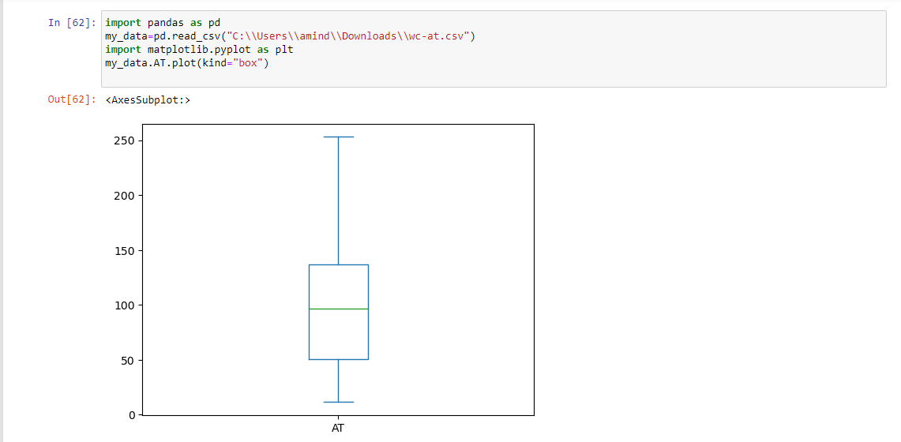

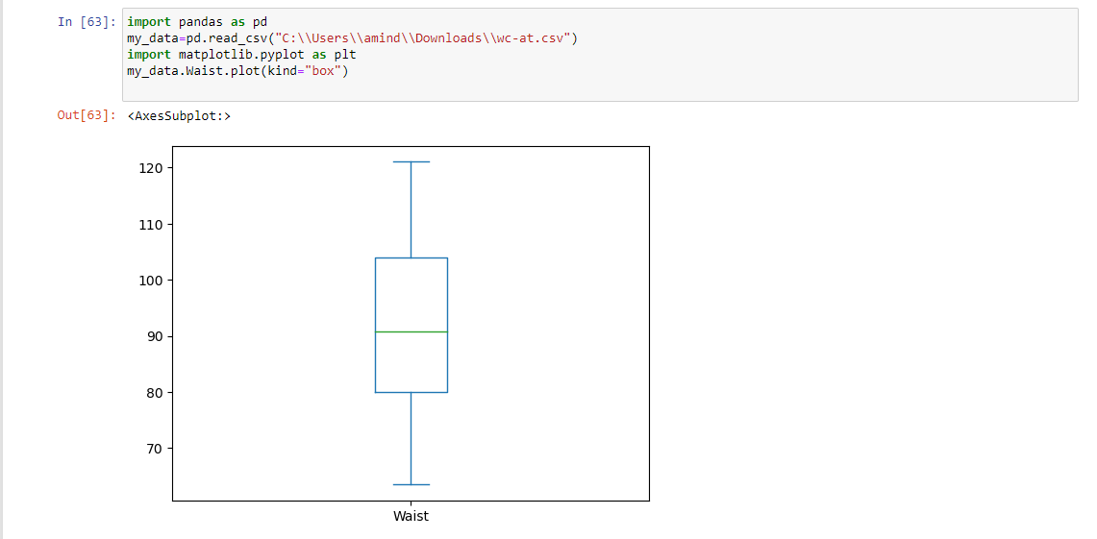

Ans) Adipose Tissue (AT) and Waist does not form Normal Distribution.

Q 22) Calculate the Z scores of 90% confidence interval,94% confidence interval, 60% confidence interval
Ans)Z score for 90% Confidence Interval = -1.6449
Z score for 94% Confidence Interval = -1.8808
Z score for 60% Confidence Interval = -0.8416
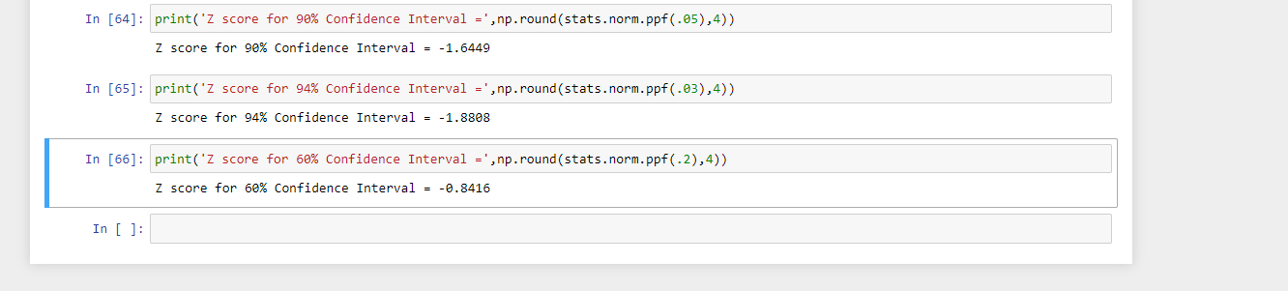

Q 23) Calculate the t scores of 95% confidence interval, 96% confidence interval, 99% confidence interval for sample size of 25
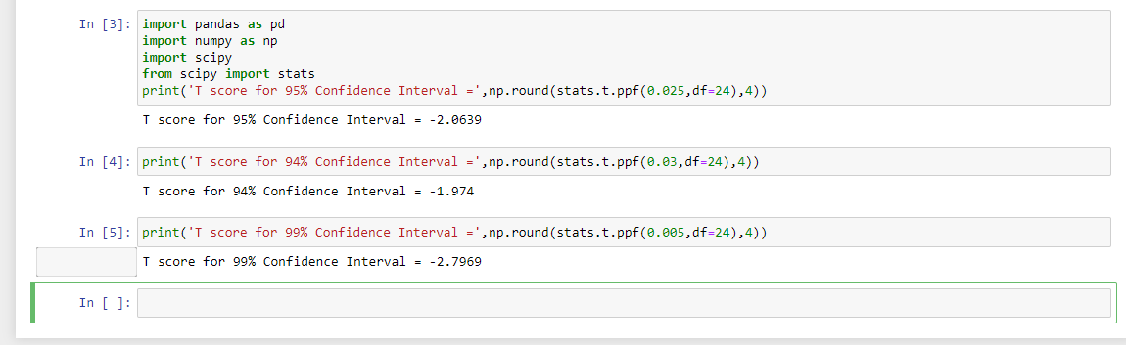
Ans) a)T score for 95% Confidence Interval = -2.0639
b)T score for 94% Confidence Interval = -1.974
c)T score for 99% Confidence Interval = -2.7969

Q 24) A Government company claims that an average light bulb lasts 270 days. A researcher randomly selects 18 bulbs for testing. The sampled bulbs last an average of 260 days, with a standard deviation of 90 days. If the CEO's claim were true, what is the probability that 18 randomly selected bulbs would have an average life of no more than 260 days
Hint:
rcode → pt(tscore,df)
df → degrees of freedom
Ans) t_score= -0.4714045207910317
P_value = 0.32167253567098353

Probability that 18 randomly selected bulbs would have an average life of no more than 260 days is 32.17%. Assuming significance value α=0.05(standard value). Thus,as p_value > ɑ; Accept Ho i.e. The CEO claims are false and the avg life of bulb > 260 days
= 0.32167253567098353

